Status Bars on website (hyperlinks)

* [Home](https://icbeem.iba-suk.edu.pk/index.html) [About](https://icbeem.iba-suk.edu.pk/about-us.html) [Speakers](https://icbeem.iba-suk.edu.pk/speakers.html) [Posters](https://icbeem.iba-suk.edu.pk/03-iCBEEM%20-%2022%20%20Poster%20A3-01.jpg) [Sponsors](https://icbeem.iba-suk.edu.pk/sponsors.html) [Travels & Accommodations](https://icbeem.iba-suk.edu.pk/Travel-accomodation.html) [Contact](https://icbeem.iba-suk.edu.pk/Contact-Us.html)

[Home](https://icbeem.iba-suk.edu.pk/index.html)

### 1st National Case writing competition

### SIBAU

### 31st October 2024

### 

###### **21-22 October 2022**

[SUBMIT CASES](https://cmt3.research.microsoft.com/ICBEEM2022/Submission/Index) [REGISTER YOURSELF](https://forms.gle/qXidA9saEqSYJzNdA)

### *Patron's Message*

|  |  |
| --- | --- |
|  |  |

Welcome to the First National Case Writing Competition, a significant initiative that reflects Sukkur IBA University's commitment to excellence in education and research. As an AACSB-accredited institution, Sukkur IBA University stands among the top 6% of business schools globally. This prestigious accreditation underscores our dedication to providing a world-class business education that aligns with international standards.

Our BS Accounting and Finance program, recognized by the Association of Chartered Certified Accountants (ACCA) UK, offers the maximum exemption of 9 out of 13 courses. This achievement highlights our continuous efforts to enhance academic quality and ensure that our students are equipped with the knowledge and skills needed to succeed in today's competitive business environment.

The National Case Writing Competition is an incredible opportunity for students, professionals, and academia to collaborate and address real-world business challenges. Through this competition, we aim to cultivate a research-oriented culture that promotes critical thinking, innovation, and practical solutions to the pressing issues facing local businesses and industries.

We look forward to seeing the brilliant ideas and strategies that emerge from this competition and are excited about the positive impact they will have on both academia and industry.

Best wishes to all the participants!

**Prof. Dr. Asif Ahmed Shaikh**  
Vice Chancellor, Sukkur IBA University

**Message from the Dean, Faculty of Management Sciences**

I am delighted to welcome you to the First National Case Writing Competition, a pioneering initiative that reflects the core values and academic excellence of Sukkur IBA University. As an AACSB-accredited institution, our university is recognized among the top 6% of business schools globally, a testament to the world-class education we provide.

The Faculty of Management Sciences has always been at the forefront of fostering innovation, critical thinking, and industry-relevant research. Our commitment to producing industry-ready graduates is evident through our high standards in teaching, research, and professional development. The success of our BS Accounting and Finance program, which enjoys the maximum exemption of 9 out of 13 courses from ACCA UK, showcases our faculty's dedication to quality education and global competitiveness.

The National Case Writing Competition offers a unique platform for students, faculty, and industry professionals to collaborate on solving real-world business challenges, reinforcing the practical application of management education. I am confident that this competition will ignite a spirit of inquiry, creativity, and leadership among participants, contributing to both personal growth and the broader advancement of our industry.

I wish all participants the best and look forward to the impactful ideas that will emerge from this prestigious competition.

**Prof. Dr. Niaz Ahmed Bhutto**  
Dean, Faculty of Management Sciences  
Sukkur IBA University

**Guidelines for** *Case Submission*

We will strictly follow the double blind peer review process. All papers sent for review will be anonymous and will not contain any information about authors. Kindly use the case submission system at the competition website to submit your structured cases. Your questions or comments should be sent to sibacrc@iba-suk.edu.pk

HYPERLINKS FOR THESE:

[Guidelines for Case Submission](https://icbeem.iba-suk.edu.pk/Paper%20&%20Case%20Submission%20Guidelines.pdf) [Tutorial-How to Submit](https://icbeem.iba-suk.edu.pk/Video.mp4)

### Guest Speakers

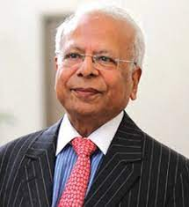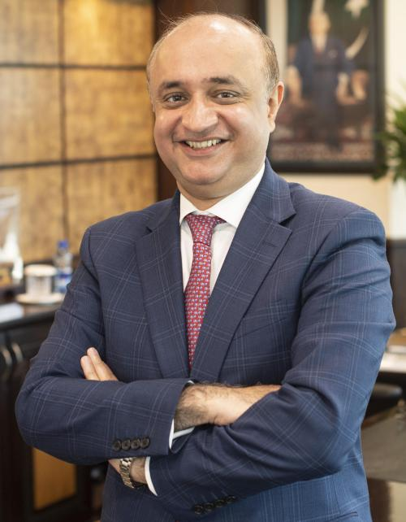

**Mr. Ahmed Hayat Lak Ishrat** **Husain**

**MD / CEO****Economist** & **Dean**

Managing Director /CEO OGDCL Institute of Business Administration

.

### Registration *Details*

[REGISTRATION FEE](https://icbeem.iba-suk.edu.pk/#nov20) [IMPORTANT DATES:](https://icbeem.iba-suk.edu.pk/#nov21) [BANK DETAILS](https://icbeem.iba-suk.edu.pk/#nov22)

* **EARLY BIRD REGISTRATION**
* For local Participants (Students)
* For local Participants (professional)
* For international Participants
* For Sukkur IBA University Students
* **STANDARD REGISTRATION**
* For local Participants (Students)
* For local Participants (professional)
* For international Participants
* For Sukkur IBA University Students & Alumni

### *Organizers:*

### 

Prof. Dr. Niaz Ahmed Bhutto Dr. Niaz Hussain Ghumro

Dean Business Admn: Department Head of Business Admn: Department

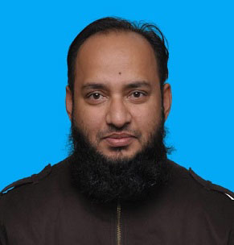

Dr. Qamaruddin Maitlo

Assistant Professor

Ms. Priah Jokhio

Research Associate CRC

### *Management Team*

* Prof. Mir M. Shah (Pro-Vice Chancellor)
* Registrar (Administrative Role)
* Mr. Oshaq Narejo (Event Management)
* Mr. Wahid Qazi & Mr. Ishfaque Lashari (Marketing)
* Mr. Hafeez Tunio (Logistics)
* Dr. Faheem Akhtar Rajpoot (Boarding)
* Mr. Hari Lal (Procurement & Resource arrangements)

[About](https://icbeem.iba-suk.edu.pk/about-us.html)

This competition aims to promote and develop 21st century case studies pertaining to Pakistani businesses and industries. There has been increased need for a realistic preview of local, Pakistani based case studies in HRM, Marketing and Entrepreneurship. The main objective of this competition is the development and promotion of real life and current case studies and dilemmas faced by business managers in 21st century.

Business situation are dynamics and rapidly changing, hence require business practitioners with an updated information and management practices that world is demanding. The focus of this competition will be on managerial issues pertaining to Entrepreneurship, HRM and Marketing in Pakistani context. The proposed outcome of this competition is quality teaching case studies in the said business domains. The case studies will be used to industry and academic practitioners to understand, develop and applying and create solutions to modern day problems in the underlying fields.

The case studies will focus on creating, values for the entrepreneurs, HRM practitioners and the marketers by applying strategies, creating processes and developing solutions. After practicing the case from this book, students, academicians and researchers will be able to make informed decisions. This book will be consisted of short and long case studies and teaching notes across various industries and regions of Pakistan and provide the readers.

### Posters

### 

### Contact Information

### Address: Nisar Ahmed Siddiqui Road, Sukkur, Sindh, Pakistan

### Email: [sibacrc@iba-suk.edu.pk](mailto:sibacrc@iba-suk.edu.pk)

### Mobile: 0320-1066283

### Phone: 071-5644400 EXT: 4698, 4419